James Carruthers
j.carruthers@newcastle.ac.uk

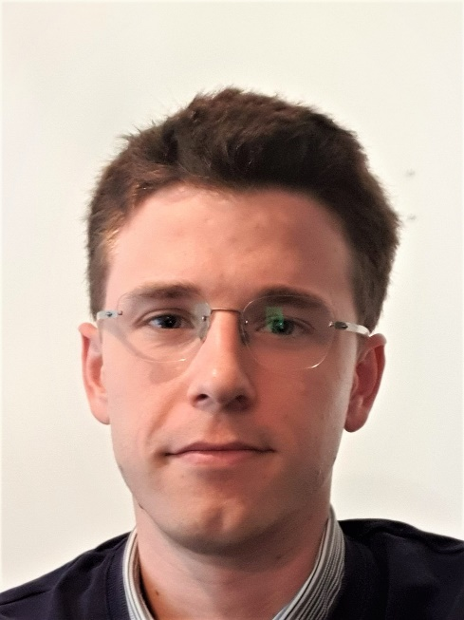
I’m interested in how we understand and communicate risks associated with climate change. Climate science has made great strides in recent years by improving our physical understanding of atmospheric dynamics and has applied this to modelling future changes in weather. However, there remain large uncertainties. This is particularly the case when considering how weather will change at local and regional scales, which is of most interest to those making decisions about adapting to climate risk.
My research project will be investigating how to apply insights from climate modelling in a way which is useful to risk decision makers. In particular, I will be examining outputs from new high-resolution convection permitting models, which can better simulate extreme precipitation and other weather from convective storms. Whereas extreme weather risk analysis has traditionally focused on a probabilistic approach in order to understand the likelihood of extreme events, this project will investigate the use of deterministic scenarios. These scenarios will relate to plausible future weather patterns which may occur due to climate change and how this will impact risks from extreme weather.
My research project is partnered with the Willis Research Network at Willis Towers Watson.

Supervisors
Dr Selma Guerreiro – Newcastle University
Prof Hayley Fowler – Newcastle University
Geoffrey Saville – Willis Towers Watson

